Interpolation-prediction networks for irregularly sampled time series

We describe our proposed Deep Interpolation Network (DIN) for clustering the patients based on their vital sign data during the early stages of hospital admission. Using the raw sparse and irregularly sampled time series vital sign as the input, DIN can automatically extract a unified and abstract representation of the entire time-series data of an encounter via an end-to-end unsupervised manner. The overall network architecture consists of four main compounds: **Interpolation model**, **Seq2Seq model**, **Re-interpolation model** and **Clustering model.**

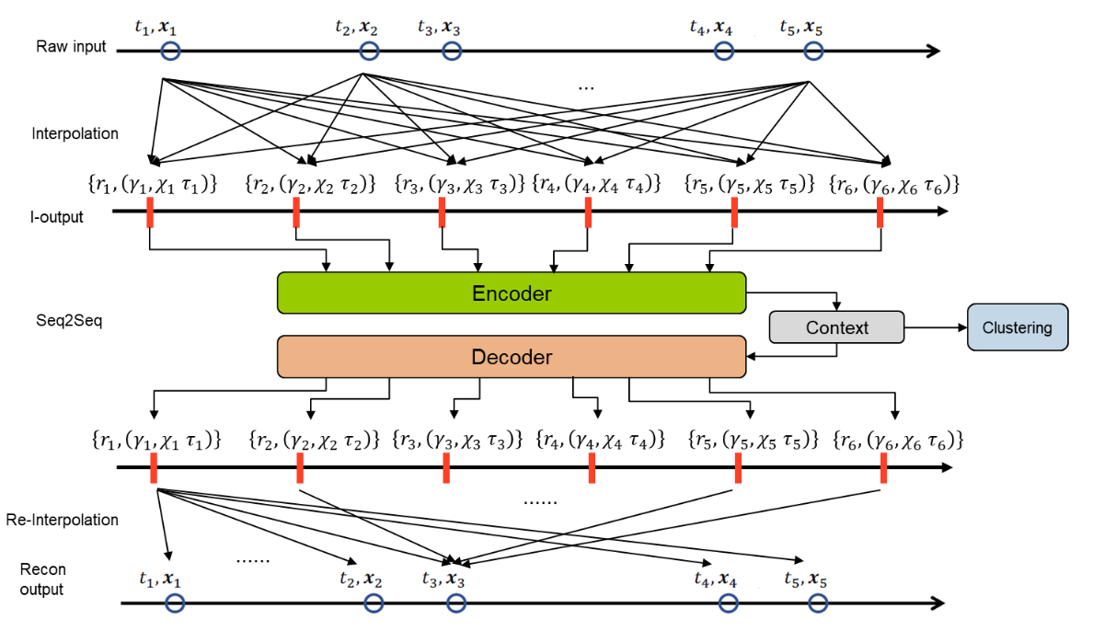

Architecture of Deep Interpolation Network for patient clustering. In the interpolation and re-interpolation process, values at each raw time point contribute to all the referenced time points in the interpolation phase and vice versa in the re-interpolation phase.

Development of Physiologic Signatures Using Vital Signs Time Series We selected six vital signs, ubiquitously and repeatedly measured during hospitalization, representing **unique physiologic responses-systolic and diastolic blood pressure, heart rate, respiratory rate, temperature, and peripheral capillary oxygen saturation**. For each vital sign, raw time series within the first six hours of hospital admission were processed to remove outliers and assess distributions, missingness, and correlation.

**Interpolation Model**

It is common that the time series vital sign data in electronic health records to be both sparse and irregularly sampled, which means large and irregular intervals widely exist between the data observation time points. To deal with this problem, we interpolate the raw time-series data to a regularly sampled meta-representation with pre-defined reference time points and with evenly spaced interval.

The interpolation model consists of two layers, where the first layer separately performs the interpolation for each variable, and the second layer aggregates the information across all the variables. The model generates three different channel groups at each reference time point, which respectively represents **local observation frequencies 𝜆, smooth trends 𝜒, and short time-scale transients 𝜏**. The interpolation model enables the single observation data point to be considered by all the reference time points and allows for the information to be shared across multiple variables

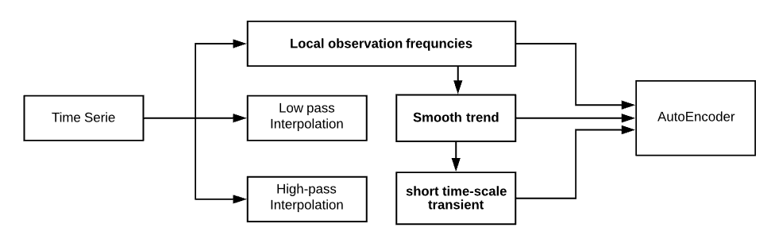

The first interpolation layer performs a semi-parametric univariate interpolation for each of the D time series separately while the second layer merges information from across all of the D time series at each reference time point by taking into account the correlations among the time series.

**Seq2Seq Model**

With the interpolated time-series data as the input, we develop a Seq2Seq model to learn its **low-dimensional representation**, which can embed **the contextual information over the fulltimeline**. Seq2Seq model is a method of the encoder-decoder framework that maps an input of sequence to an output of sequence.